Freddie Manyate 202105348 NDBS EXAM
Question 1
  - To implement this, I believe that we have to use hashes, that way we can store information like the title question and tags and also the views in one hash
This is the key pattern I am going to use keep track of who posted the question and also to be able to query all questions asked by this person (user1:question1)
For the answer I will have a different key pattern (user1:question1:answer1:user3), this way we can keep track of the question being answered since the ~user1:question1~ gives us the question in hand and then the ~answer1:user3~ gives the answer and the person who responded
To count the number of responses to a

1.2 HMSET user1:question1 title "The Title" question "The question" tag1 "The first tag" tag2 "The second tag"
1.3 HSET user1:question1:answer1:user3 answer "This is the answer"
1.4 Skipped
1.5 HINCRBY user1:question1 views 1 //This adds a new field if there is no ‘views’ field or just increments when there is

Question 2
2.1. SET plate1 “WDF532NC” SET plate2 “SDF123NC”
GETRANGE plate1 -2 -1

2.2. I can use a set to hold the IDs of users currently in the chat and when they leave I just use SREM to remove them from the set, this way I can also get the number of members in the set
- SADD chat1:users “User1”
- SREM chat1:users “User1”
- SCARD chat1:users

Question 3
3.1 For this I am going to have two keyspaces named weatherDetails and places, the weather information will be stored in the weatherDetails keyspace and the name of the city and the postal code in the places keyspace. The id of the weatherDetails will referenced in the places keyspace, in that way when your search keyword matches either the name of the city or the postal code, we will get the weatherID and therefore be able to make a query to get the weather information

3.2 weatherID = "weather1"
db.weatherDetails.insertOne({
"_id":weatherID,
"currentTemp": 15,
"high":31,
"low":15,
"humidity":"60%",
"pressure":"1016.6 mb",
"visibilty":"Unlimited",
"wind":"5 km/h",
"Dew point":7,
"UV Index": "0 of 11",
"Moon Phase":"Full",
"HourlyTemp":[15, 15, 15, 19, 24],
"HourlyRain":["0%","0%","0%","0%","0%"]})

db.places.insertOne({
"_id":"place1",
"PostalCode": 1234,
"Name": "Rietondale",
"Province":"Gauteng",
"weather":weatherID})

3.3 postalCode = 1234
db.places.aggregate([
{$match: {PostalCode:postalCode}},
{$project: {"Name":1}}])
Question 4
4.1. db.Sales.aggregate([
{
$match:{
storeLocation:"London"
}
},
{
$count:"Number of sales"

}
]);
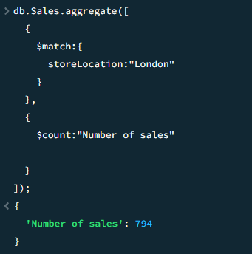

4.2 db.Sales.aggregate([
{$unwind: "$items"},
{$group:{_id:"$items.name", itemprice:{$max:"$items.price"}}},
{$sort: {itemprice:-1}},
{$limit:1}

])
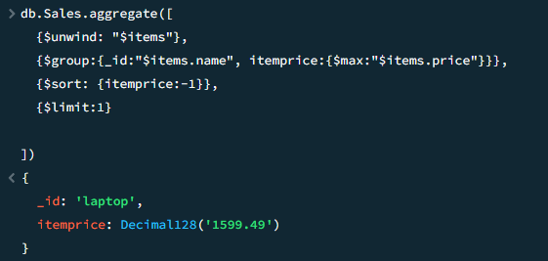

4.3 db.Sales.aggregate([
{
$match:{
saleDate:{$gt:ISODate("2016-04-05")}
}
},
{
$count:"Number of sales"

}
]);
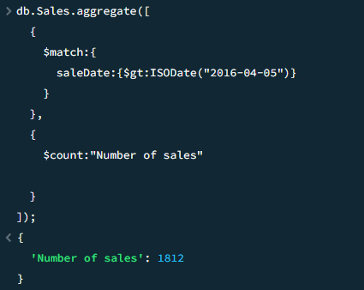

4.4 db.Sales.aggregate([
{
$group: {
"_id": "$purchaseMethod",
"count": {$sum:1}
}
},
])
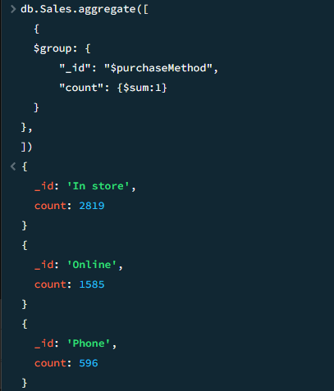

Question 5
5.1 For the user_id, I can use an integer as primary key then use a string for the username, string for email, date data type for the date of birth a set for the interest so that they do not store movies twice for example([movies, movies]), a set for the friend id’s because one person can have multiple friends but they can’t have the same friend twice, for posts I can use a map of a UDT that has post details since one user can have multiple posts

5.2 CREATE TYPE post(content text, hashtags list<text>,created_at timestamp);
CREATE TABLE user(user_id text PRIMARY KEY, usernme text, email text, date_of_birth date, interests set<text>, friends set<text>, posts list<frozen<post>>);

INSERT INTO user(user_id, usernme, email, date_of_birth, interests, friends, posts) VALUES('111', 'johndoe', 'johndoe@gmail.com', '1969-12-31', {'music', 'movies'}, {'112'}, [{content:'Weekend movie night!', hashtags:['#comedy', '#movies'], created_at: toTimeStamp(1650739200)}]) ;
INSERT INTO user(user_id, usernme, email, date_of_birth, interests, friends, posts) VALUES('112', 'janedoe', 'janedoe@gmail.com', '1969-12-31', {'travel', 'photography'}, {'111', '113'}, [{content:'Just landed in Paris!', hashtags:['#travel', '#france'], created_at: toTimeStamp(1650742800)}, {content:'Trying out this new camera', hashtags:['#photography', '#gear'], created_at:toTimeStamp(1650745200)}]) ;

5.3 ALTER TABLE user ADD city text
5.4 UPDATE user SET city ='Kimberley' WHERE user_id='111';

Question 6
6.1 I I will have two nodes, one will store the user_id and name, and the other will store the transaction information, then model a relationship between the two nodes (MADE_PURCHASE)

6.2 CREATE (:userNode {user_id:1, name:"Alice"})
CREATE (:userNode {user_id:2, name:"Bob"})
CREATE (:userNode {user_id:3, name:"Charlie"})

LOAD CSV WITH HEADERS FROM 'file:///Book1.csv' AS row
CREATE(:transaction{
transaction_id:row.transaction_id,
transaction_data:row.transaction_date,
transaction_amount:toInteger(row.transaction_amount),
is_fraud:row.is_fraud,
reason:row.reason,
user_id:toInteger(row.user_id)
})

MATCH (u:userNode), (t:transaction)
WHERE u.user_id = t.user_id
CREATE (u)-[:MADE_PURCHASE]->(t)
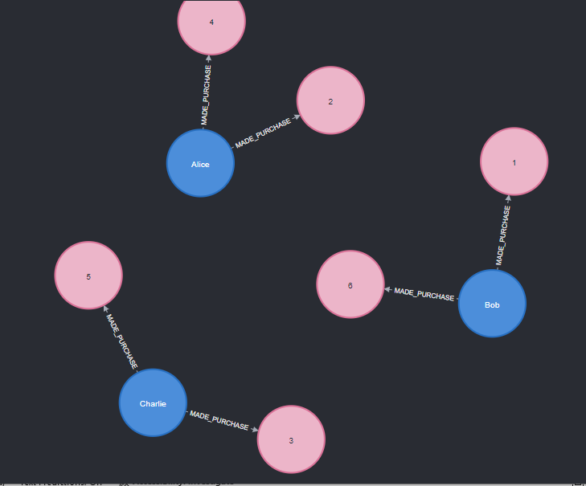

6.3 MATCH (t:transaction)
WHERE t.transaction_data>'2024-03-25'
RETURN t

6.4 Skipped

6.5 MATCH (t:transaction)
WHERE t.user_id=3

RETURN SUM(t.transaction_amount) AS totalByAlice
